Lab 1: Password Cracking Tools
While doing this lab I learned how Cain & Abel works. How to make sure PWdump7 is working and doing its job. How to brute a hash and to detect the rootkit.

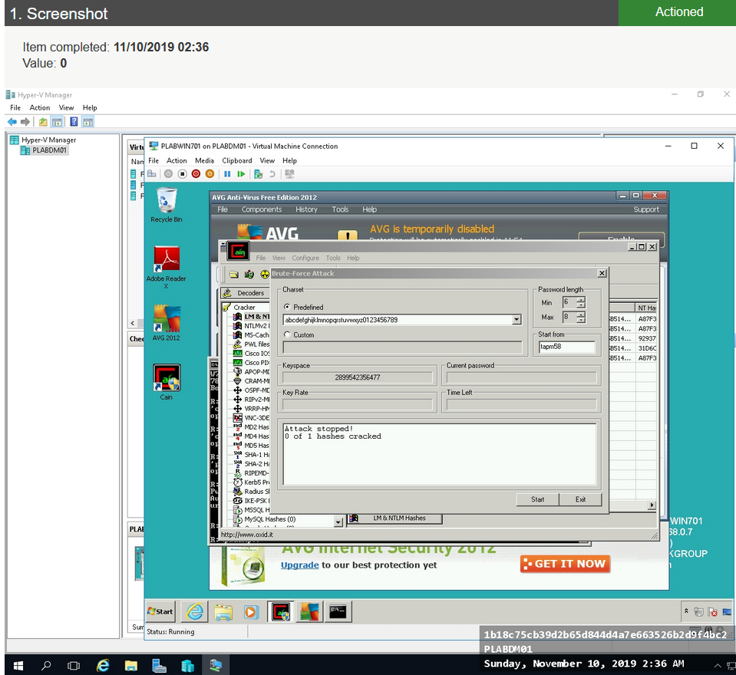
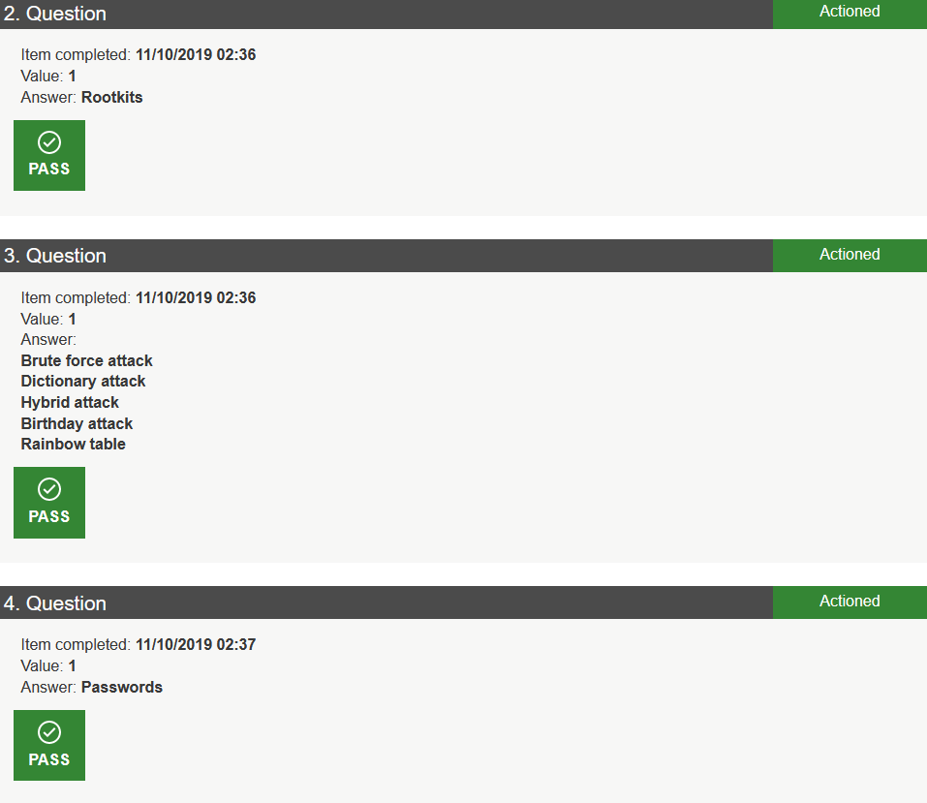

Lab 2: Application Data - Establish Host Security
Learned how to establish a way to look over your pc and to secure it.
